**Difference between Information and Data**

Data and Information are important concepts in the world of computing and decision-making. Data is defined as unstructured information such as text, observations, images, symbols, and descriptions on the other hand, Information refers to processed, organized, and structured data. It gives context to the facts and facilitates decision-making.

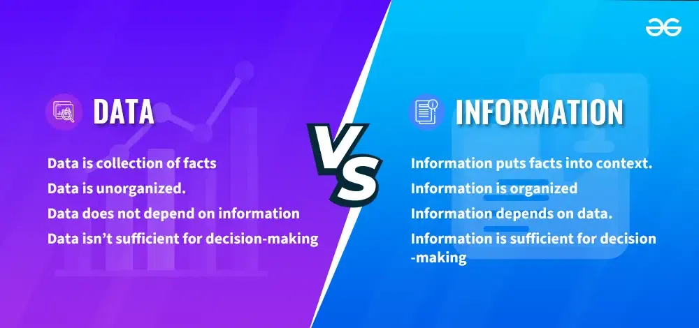Data Vs Information

**What is Data?**

*Data is a raw and unorganized fact that is required to be processed to make it meaningful. It can be considered as facts and statistics collected together for reference or analysis.*

[Data](https://www.geeksforgeeks.org/what-is-data/)are individual units of information. In analytical processes, data are represented by variables. Data is always interpreted, by a human or machine, to derive meaning. So, data is meaningless. Data contains numbers, statements, and characters in a raw form.

**Types of Data**

There are two types of Data:

1. **Quantitative:**Quantitative data refers to numerical informationlike weight, height, etc.
2. **Qualitative:**Qualitative data refers to non-numeric informationlike opinions, perceptions, etc.

**What is Information?**

*Information is defined as structured, organized, and processed data, presented within a context that makes it relevant and useful to the person who needs it. Data suggests that raw facts and figures regarding individuals, places, or the other issue, that is expressed within the type of numbers, letters or symbols.*

Information is the knowledge that is remodeled and classified into an intelligible type, which may be utilized in the method of deciding. In short, once knowledge ends up being purposeful when conversing, it’s referred to as info. It’s one thing that informs, in essence, it provides a solution to a specific question. It may be obtained from numerous sources like newspapers, the internet, television, people, books, etc.

**Difference between Information and Data**

| **S.NO** | **DATA** | **INFORMATION** |
| --- | --- | --- |
| **Definition** | Data is defined as unstructured information such as text, observations, images, symbols, and descriptions. In other words, data provides no specific function and has no meaning on its own. | Information refers to processed, organized, and structured data. It gives context for the facts and facilitates decision making. In other words, information is processed data that makes sense to us. |
| **Purpose** | Data are the variables that help to develop ideas/conclusions. | Information is meaningful data. |
| **Nature** | Data are text and numerical values. | Information is refined form of actual data. |
| **Dependence** | Data doesn't rely on Information. | While Information relies on Data. |
| **Measurement** | Bits and Bytes are the measuring unit of data. | Information is measured in meaningful units like time, quantity, etc. |
| **Structure** | As tabular data, graphs, and data trees can be easily structured. | Information can also be structured as language, ideas, and thoughts. |
| **Purposefulness** | Data does not have any specific purpose | Information carries a meaning that has been assigned by interpreting data. |
| **Knowledge Level** | It is low-level knowledge. | It is the second level of knowledge. |
| **Decision Making** | Data does not directly help in decision making. | Information directly helps in decision making. |
| **Meaning** | Data is a collection of facts, which itself has no meaning. | Information puts those facts into context. |
| **Example** | Example of data is student test scores. | Example of information is average score of class that is derived from given data. |

**Examples of Data vs. Information**

**Data Example**

* **Temperature Readings: Numbers representing temperature throughout the day, such as**"72°F", "68°F", "75°F"**.**
* **Student Grades**:A list of numerical scores obtained by students on a test, like "85", "92", "78".
* **Stock Prices**: Daily closing prices of a company's stock, such as "$50.25", "$48.90", "$52.10".

**Information Example**

* **Weather Report:** Based on the temperature reading a weather report can be generated.
* **Grade Average:**Based on the student grades, the average grade of class can be derived.
* **Market Analysis:**The stock market showed a slight increase today derived from stock prices.

In each case, the raw data ( temperature readings, student grades, stock prices) becomes meaningful information after being processed, analyzed, and presented in a relevant context.

**Database**

A **database** is a structured collection of data that can be easily accessed, managed, and updated. It organizes data in the form of tables, schemas, views, and reports. For example, a college database might store information about students, faculty, and courses

A **Database Management System (DBMS)** is a software that enables users to define, create, maintain, and control access to databases. It provides an interface for performing various operations such as database creation, data storage, data retrieval, data update, and data deletion

A **database system** is an organized collection of structured information or data, typically stored electronically in a computer system. It is usually controlled by a database management system (DBMS), which serves as an interface between the database and its end users or programs. The combination of the data, the DBMS, and the applications associated with them is referred to as a database system.